


Temora
Floodplain Risk Management Study and Plan

To Residents and Business Owners of Temora:
Temora Shire Council has engaged consultants to undertake the Temora Floodplain Risk Management Study and Plan. The study is jointly funded by Council and the NSW Department of Planning, Industry and Environment and aims to build community resilience towards flooding through informing better planning of development, emergency management and community awareness. Council has established a Floodplain Risk Management Committee which is comprised of relevant council members, state government agencies and community representatives. If you are interested in joining the Floodplain Risk Management Committee as a community representative, then please register your interest with Council using the contact details below.
The Floodplain Risk Management Study and Plan will build on the results of the Temora Flood Study which was completed in 2019 and defined flood behaviour at Temora under present day conditions. The figure over the page shows the indicative extent of the 1 in 100 annual exceedance probability (AEP) flood within the extent of the study area which covers both the Trigalong Creek catchment and the urbanised parts of the town. An electronic copy of the Temora Flood Study can be accessed at the following link:
https://flooddata.ses.nsw.gov.au/dataset/temora-flood-study-report
The flood models originally developed as part of the Temora Flood Study will be updated as part of the Floodplain Risk Management Study and Plan and validated against observed flood behaviour from the storm event that occurred in Temora on 23 March 2021.
The main aim of the Floodplain Risk Management Study and Plan is to assist Council in refining strategic plans for mitigating and managing the effects of existing flood risk (associated with existing development on flood prone land), future flood risk (associated with any new development on flood prone land) and continuing flood risk (the risk remaining in both existing and future development areas after floodplain risk management measures are implemented).
Have Your Say on Floodplain Management
An important step in the Floodplain Risk Management Study and Plan is to appraise what flood related issues are important to the community. The attached questionnaire has been provided to residents and businesses to assist the Consultant in gathering this important information. All information provided will remain confidential and for use in this study only. Please return the completed Questionnaire to Council’s offices or email a scanned copy to temora@lyallandassociates.com.au by Friday 23 July 2021.
Contact: Temora Shire Council
Claire Golder | Town Planner/Strategic Projects Officer
Phone: (02) 6980 1108
Email: cgolder@temora.nsw.gov.au
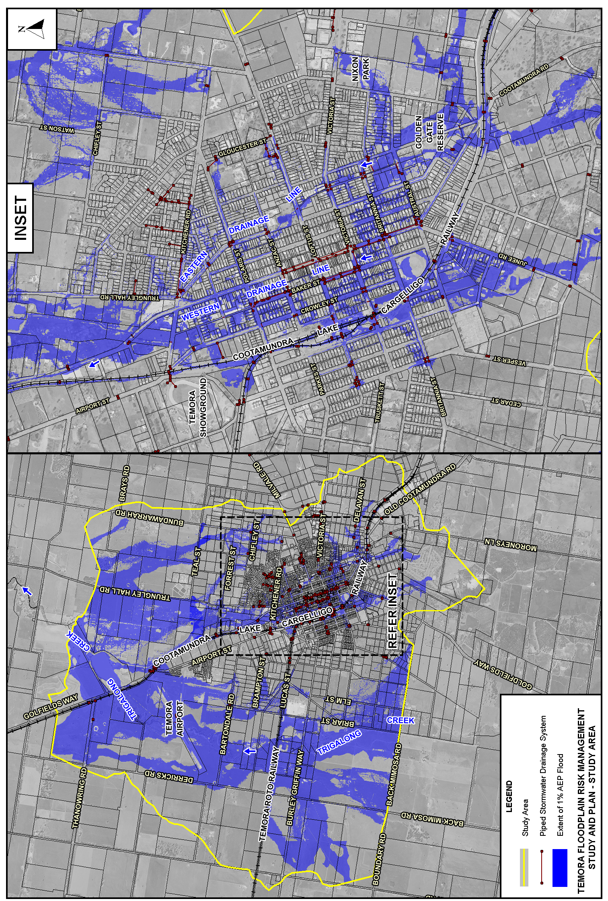

This Questionnaire is part of the Temora Floodplain Risk Management Study and Plan which is currently being undertaken by Temora Shire Council with the financial support of the NSW Department of Planning, Industry and Environment. Your responses to the questionnaire will help us determine the flood issues that are important to you.
Please return your completed Questionnaire to Council offices or email a scanned copy to temora@lyallandassociates.com.au by Friday 23 July 2021.

1. Your name (optional):
Address:

About your property
- Please tick as appropriate:
I am a resident
I am a business owner
Other (please specify __________________)
- How long have you been at this address?
Less than a year
1 year to 5 years
5 years to 20 years
More than 20 years ( ____ years)
- Please select which best describes your property type?
House
Townhouse/Unit/Apartment
Vacant land
Shop/Retail
Industrial Unit/Warehouse/Factory
Community building
Other: ____________________________
Your Experiences of Flooding
- Have you ever been affected by flooding?
Yes (please continue to Question 6)
No (please skip to Question 10)
- If you answered “Yes” to Question 5, on what dates were you affected by flooding?
3 March 2012
21 September 2016
23 March 2021
Other: ____________________________

- For the floods you have listed, do you have any records of the height the floodwaters reached? For example, a flood mark on a building, shed, fence, light pole? (please provide brief description)
_______________________________________
_______________________________________
_______________________________________
_______________________________________
_______________________________________
_______________________________________

- If flooding affected your property in the past, what damages occurred as a result?
_______________________________________
_______________________________________
_______________________________________
_______________________________________
_______________________________________
_______________________________________
_______________________________________

- If you have any photographs of historic flooding at Temora you are welcome to drop into Council’s office in Temora to have them photocopied or email them directly to the Consultant at temora@lyallandassociates.com.au.

Your attitudes to Council’s development controls
- Please rank the following development types according to which you think are the most important to protect from floods
(1=highest priority to 6=least priority)
Commercial
Residential
Essential community facilities
Critical Utilities
Minor developments and additions
New residential subdivisions
- What level of control do you consider Council should place on new development to minimise flood-related risks?
(Tick only one box)
(In addition to being favoured by the Community, these options would also need to comply with legislation)
Prohibit all new development on land with any potential to flood
Prohibit all new development only in those locations that would be extremely hazardous to persons or property due to the depth and/or velocity of floodwaters, or evacuation difficulties.
Place restrictions on developments which reduce the potential for flood damage (e.g. minimum floor level controls or the use of flood compatible building materials)
Advise of the flood risks, but allow the individual a choice as to whether they develop or not, provided steps are taken to minimise potential flood risks
Provide no advice regarding the potential flood risks or measures that could minimise those risks
Don’t know
- What notifications do you consider Council should give about the potential flood affectation of individual properties?
(Tick only one box)
Advise every resident and property owner on a regular basis of the known potential flood threat
Advise only those who enquire to Council about the known potential flood threat
Advise prospective purchasers of property of the known potential flood threat.
Provide no notifications
Other (__________________________)
Your opinions on floodplain risk management measures

- Below is a list of possible options that may be looked at to try to minimise the effects of flooding in the study area.
This list is not in any order of importance and there may be other options that you think should be considered. For each of the options listed, please indicate “yes” or “no” to indicate if you favour the option. Please leave blank if undecided.

Option | Yes | No | Don’t Know
Management of vegetation along creek corridors to provide flood mitigation, stability, aesthetic and habitat benefits
Widening of watercourses
Construct detention basins
Construction of permanent levees/diversion banks to contain floodwaters
Improve stormwater drainage system
Upgrade culverts beneath roads/railways
Removal of floodplain obstructions
Voluntary purchase of the most severely affected flood-liable properties
Provide funding or subsidies to raise houses above major flood level in low hazard areas.
Flood proofing of individual properties by waterproofing walls, putting shutters across doors, etc.
Specify controls on future development in flood-liable areas (e.g. controls on extent of filling, minimum floor levels, etc.)
Provide a Planning Certificate to purchasers in flood prone areas, stating that the property is flood affected.
Ensuring all information about the potential risks of flooding is available to all residents and business owners
Improve flood warning and evacuation procedures both before and during a flood.
Community education, participation and flood awareness programs.
Ensuring all residents and business owners have Flood Action Plans - these outline WHAT people should do, WHERE they should go and WHO they should contact in a flood

Other Information
- What do you think is the best way for us to get input and feedback from the local community about the results and proposals from this study?
(Tick one or more boxes)
Council’s website
Articles in local newspaper
Open days or drop-in days
Community workshops
Public Meetings
Through Council’s Floodplain Management Committee
Other (please specify _______________)

- If you wish us to contact you so you can provide further information, please provide your details below:
Name:
Address:

Phone:
Email:

Who can I contact for further information?

Temora Shire Council
Claire Golder | Town Planner/Strategic Projects Officer
Phone: (02) 6980 1108
Email: cgolder@temora.nsw.gov.au

COMMENTS
Please write any additional comments here:

